INDEX

S.No. | Experiment | Sign
1. | Write a C++ program to print your personal details name,
 | surname(single character), total marks, gender(M/F), result(P/F)
 | by taking input from the user.
2. | Create a class called 'Employee' that has “Empnumber‟ and
 | “Empname‟ as data members and member functions getdata( ) to
 | input data display() to output data. Write a main function to
 | create an array of ‟Employee‟ objects. Accept and print the
 | details of at least 6 employees.
3. | Write a C++ program to swap two number by both call by value
 | and call by reference mechanism, using two functions
 | swap_value() and swap_reference respectively , by getting the
 | choice from the user and executing the user’s choice by switch-
 | case.
4. | Write a C++ program to create a simple banking system in which
 | the initial balance and the rate of interest are read from the
 | keyboard and these values are initialized using the constructor.
 | The destructor member function is defined in this program to
 | destroy the class object created using constructor member
 | function. This program consists of following member functions:
 | i. Constructor to initialize the balance and rate of interest
 | ii. Deposit - To make deposit
 | iii. Withdraw – To with draw an amount
 | iv. Compound – To find compound interest
 | v. getBalance – To know the balance amount
 | vi. Menu – To display menu options
 | vii. Destructor
5. | Write a program to accept five different numbers by creating a
 | class called friendfunc1 and friendfunc2 taking 2 and 3 arguments
 | respectively and calculate the average of these numbers by
 | passing object of the class to friend function.
6. | Write a program to accept the student detail such as name and 3
 | different marks by get_data() method and display the name and
 | average of marks using display() method. Define a friend class for
 | calculating the average of marks using the method mark_avg().
7. | Write a C++ program to perform different arithmetic operation
 | such as addition, subtraction, division, modulus and multiplication
 | using inline function.
8. | WAP to return absolute value of variable types integer and float
 | using function overloading.

- WAP to perform string operations using operator overloading in C++

  - = String Copy
  - ==,<,> Equality
  - + ConcatenatioN

- Consider a class network of figure given below. The class master derives information from both account and admin classes which in turn derive information from the class person. Define all the four classes and write a program to create, update and display the information contained in master objects. Also demonstrate the use of different access specifiers by means of member variables and member functions.

- Write a C++ program to create three objects for a class named pntr_obj with data members such as roll_no and name . Create a member function set_data() for setting the data values and print() member function to print which object has invoked it using ‘this’ pointer.

- Write a C++ program to explain virtual function (polymorphism) by creating a base class c_polygon which has virtual function area(). Two classes c_rectangle and c_triangle derived from c_polygon and they have area() to calculate and return the area of rectangle and triangle respectively.

- Write a program to explain class template by creating a template T for a class named pair having two data members of type T which are inputted by a constructor and a member function get-max() return the greatest of two numbers to main. Note: the value of T depends upon the data type specified during object creation.

- Write a C++ program to illustrate

  - Division by zero

  - Array index out of bounds exception
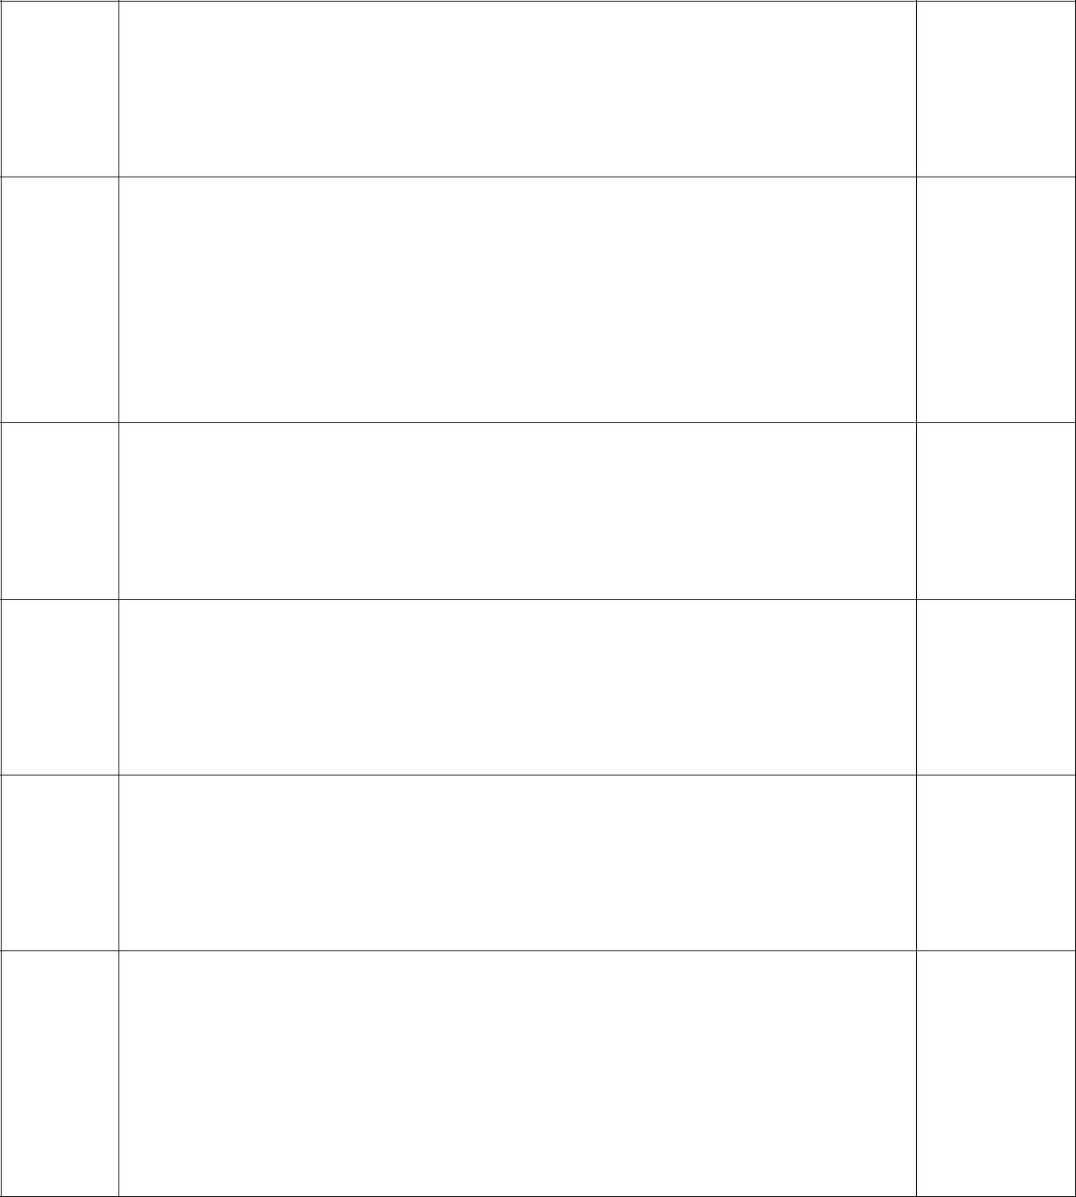

Also use multiple catch blocks.

